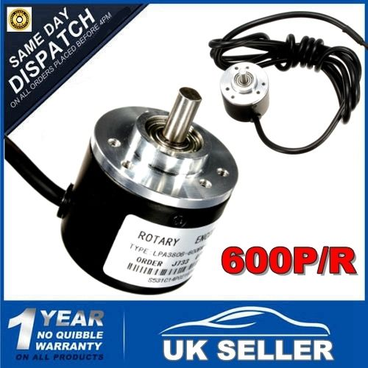

Detail:  
  
Color: Like the picture show  
Quantity: 1 pc  
Model: incremental rotary encoders,AB two phases  
600P/R-600 pulses per revolution.  
DC 5-24V power supply.  
Maximum mechanical speed of 6000 rev / min.  
The response frequency: 0-20KHz  
  
Size:  
Encoder size: 39 x 35.5mm,Shaft 6 x 13mm  
Axis stopper platform: High 5mm, 20mm  
Fixed empty as: three 3mm screw holes distribution of 120 degrees / or six 3MM screw holes into 60 degree distribution,to the center distance of 14mm.  
Wires length: 188cm / 74"  
  
Features:  
- Light weight and small size.  
- By rotating the grating disk and optocoupler direction which generate counting pulses.  
- Easy installation.  
- Fits for measuring the rotational speed of the object , angle, acceleration, and length measurement.  
  
Output:  
AB two -phase quadrature output rectangular pulse ,the circuit output is NPN open collector output type ,the output of this type can and with internal pull-up resistor is directly connected MCU or PLC ,such as 51 single or Mitsubishi PLC (PLC input mode should be connected to 0V switch function ).  
Note: If the encoder is not connected to the device can not be directly oscilloscope oscilloscope ( open collector output without pull-up resistor when there is no voltage output ) If you want the oscilloscope in AB two-phase output with two pull-up resistors.  
  
Fitment:  
Suitable for a variety of intelligent control displacement measurement ,automatic fixed-length automatic guillotine paper machine,steel cut length control ,civilian measured height human scale,students racing robots.  
  
Wiring Output : A phase, B phase, Vcc positive supply, V0, the shield wire.  
Connection: Green = A phase, white = B phase, red = power +, black = power -  
Note: AB two -phase outputs must not be connected directly to VCC, otherwise, they will burn the output transistor.